Help us promote the Step into the NHS schools competitions
Stakeholder toolkit
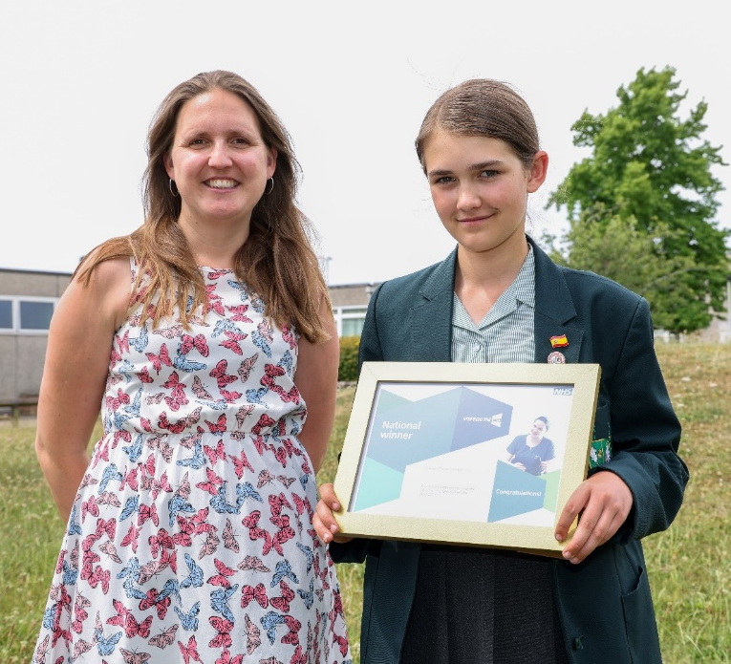

National winners of the 2021-2022 Step into the NHS primary and secondary schools competitions

Contents
Who is this toolkit for? 2
Why we need you! 2
What messages do I include? 3
When do I promote the competition? 4
Using the resources file 5
About the competition 5

Who is this toolkit for?

As an NHS ambassador or individual involved in career-related learning, we’d like you to help us promote and spread the word about the Step into the NHS schools competitions (one for primary schools and one for secondary schools) so that more young people can discover the wide range of career opportunities in the NHS and have the chance to win amazing prizes. For more information about the competitions, see the end of this document.

Why we need you!

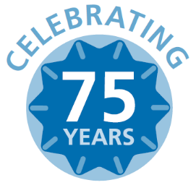
We want to reach as many schools across England as possible before the closing date of 30 April 2023. Schools will also be joining us in celebrating the NHS’ 75th birthday in 2023.

The primary schools competition asks Key Stage 2 pupils (ages 7-11) to produce a piece of artwork or writing showcase the variety of job roles in the NHS.

The secondary schools competition asks Key Stage 3 students (ages 11 – 14) to create a fun and lively job advertisement on a chosen NHS career.

How do I promote the competitions?

You may like to use the following channels to reach teachers and careers advisers:

Channel | What you can do | How we can help
Email | Do you have any school contacts you could email? Do you have any newsletters you distribute? | Use our pre-made email template (see our resources file later in this document)
Social media | Post on Facebook, Twitter and LinkedIn, which are popular with teachers | Use our pre-made copy and images in the resources file
School visits | Consider introducing the competition to students on a school visit | Use our slide pack in the resources file
Word-of-mouth | Send this toolkit to your colleagues or anyone who works with schools.  Do you have colleagues or friends who have children between 7-14 years old? Send them the primary or secondary schools families toolkit. | Our separate guides for families (one for each competition) are available on the Step into the NHS website (‘extra resources’) and details how parents/carers can support their child’s entry.

What messages do I include?

We’d like to focus on the following five key messages to teachers when promoting the competitions. They are slightly different for each competition.

Primary schools

- Introduce your pupils to over 350 NHS careers and challenge gender stereotyping in job roles

- Pupils can celebrate the NHS’ 75th birthday in 2023 by showcasing the variety of careers in the NHS

- You can now deliver the competition in one hour with the ‘one lesson launch’ resource

- The competition is bigger than ever, with the chance for winning pupils to have their entries displayed in public for everyone in their community to see. There are also Amazon vouchers, exciting goody bags and certificates to win.

- The competition has free, engaging teacher resources that align with the DfE careers strategy and KS2 curriculum.

Secondary schools

- Introduce your students to over 350 NHS careers and raise their careers aspirations

- Students can celebrate the NHS’ 75th birthday in 2023 by learning about over 350 careers in the NHS

- You can now deliver the competition in one hour with the ‘one lesson launch’ resource

- The competition is bigger than ever, with the chance for winning students to have their entries displayed in public for everyone in their community to see. There are also Amazon vouchers, exciting goody bags and certificates to win.

- The competition has free, engaging teacher resources that align with the Gatsby Benchmarks, DfE careers strategy and KS3 curriculum.

When do I promote the competition?

The competition launched in September 2022 and the closing date is 30 April 2023. You can promote throughout this period.
Here are some key events for you to be aware of:
 | Key event | Further information
January | Webinars for schools (25 and 26 January)  Email to teachers | The Step into the NHS webinar will feature NHS ambassadors talking about their jobs  The Step into the NHS team will be emailing teachers with details of the webinar and how to sign up
February | Half-term | 13-17 February (for most schools)
March | National Careers Week (6-11 March) | A Step into the NHS email will be sent to teachers
April | Closing date  Final email | The competition closes on 30 April 2023  The Step into the NHS team will be sending a final email to encourage entries
May | Regional winners chosen | Winners and highly commended entrants will be listed in our website’s new online gallery (one for primary and one for secondary)
June | Overall national winner chosen | Regional wining pupils will be invited to showcase their entries to a panel of judges over video call, who will decide the overall national winner
July | Winners announced publicly  Sign up to hear about next year | Check the winners on the Step into the NHS website, NHS Health Careers website and our Twitter account.  Teachers can sign up to be the first to hear about next years’ teaching resources and competition.

Using the resources file

Two resources files (one for primary schools and one for secondary schools) are available on the Step into the NHS website. They each contain:

- Email copy for you to send to schools
- Social media post copy with hashtags and handles
- Approved imagery to use in your communications
- A slide pack to introduce the competition in schools

Please note that the primary and secondary competitions are different in terms of the entry task and key messages (see page 3). They also have different webpages on the Step into the NHS website. Please be mindful of this if you are promoting both competitions at the same time (i.e. share both webpages rather than just one).

Thank you and good luck spreading the word!

Please email the team at stepintothenhs@hopscotchconsulting.co.uk if you have any questions.

About the competitions

The Step into the NHS primary and secondary schools competitions are held by Health Education England. They aim to open students’ eyes to over 350 careers in the NHS and raise their careers aspirations. With the NHS 75th birthday in 2023, this year is even more special.
The primary schools competition asks pupils to showcase the wide range of roles in the NHS in a unique and creative way – with a poster, card, video, poem or even a song! Watch the competition video and share it share on Twitter or Facebook.

The secondary schools competition asks students to choose an NHS career that interests them create a job advert about it that will appeal to their friends and other young people. Previous entries have included websites, short videos, board games and even a cardboard pinball machine! Watch the competition video and share it on Twitter or Facebook.

Why are we running these competitions?

The NHS is the UK’s biggest employer with 1.3 million staff employed in England in more than 350 different roles.

With so many careers and job roles available within the NHS, from dentists to plumbers and from midwifes to pharmacists, the resources and competition are vital in opening young people’s eyes to a future career in healthcare

Whereas the primary schools competition encourages pupils to challenge gender stereotyping in NHS roles, the secondary schools competition focuses more on raising young people’s career aspirations and improving their job-seeking skills.

How do schools take part?

Teachers can get started by downloading the teacher guide from the Step into the NHS website. There is one for primary schools and one for secondary schools. The teacher guides include competition information plus links to the ready-made resources to inspire students before they start their designs.

The fun and engaging resources are freely available to teachers on the Step into the NHS website and explore the vast number of careers available in the NHS. The resources can be tailored to students’ ages and abilities, and they are flexible enough to be adapted for different lessons.

See the online gallery
The online gallery will be updated with this year’s entries as we receive them. It’s a fantastic way of acknowledging schools’ hard work!

Primary schools competition online gallery
Secondary schools competition online gallery

See last year’s winning entries

Last year’s primary schools competition attracted over 900 entries from 36 schools across England, and the secondary schools competition attracted almost 900 entries from 120 schools. Both competitions provided hundreds of schools with relevant and engaging careers content to help raise their students’ career aspirations.

Primary schools competition 2021/22 – see the list of winners
Secondary schools competition 2021/22 – see the list of winners

