Step into the NHS
Family toolkit for primary school competition

Why we need you!
The Step into the NHS primary schools' competition is inviting pupils (ages 7 – 11) across England to submit a creative “thank you” – by creating a card, video, poem or even a song - to the NHS by 30 April 2021.
We understand that families at home are the most influential force in a child’s aspirations and career decision-making. More so than ever before, your engagement at home has the power to make a huge contribution to your child’s education, aspirations and attainment.

This is why we want you to be involved in encouraging and supporting your child’s entry to the competition. Your child will have started thinking about their entry and their teacher would have shared the relevant resources with them – there are some tips to help support your child’s entry further down.
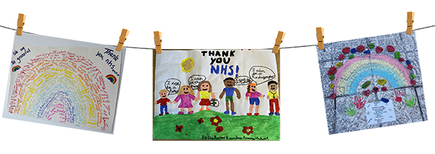
Here are some of last year’s entries:

How to support your child’s entry

- Use the Step into the NHS website to help them explore over 350 jobs within the NHS with our Careers A-Z.
- Use the careers quiz on the website with your child which suggests NHS careers based on your skills and interests.
  - Use the conversation starters below if you cannot access the website.
- Encourage your child to be creative!
  - Their entry can be made using materials around the home – paper, colouring pens, news clippings, paints - or be digital – video or digital art.
  - If your child chooses to film a video, they might need your help. Try to film in a space with lots of light, like near a window or a lamp.
- Help your child send their entry to their teacher before 30 April.

Conversation starters
If you wonder how best to start conversations with your child about NHS careers, use the prompts below to highlight which NHS careers they might take interest in. Use positive language and take your time when exploring your child’s answers.

- What is your favourite topic at school? Could an NHS job involve it?
- What would you like to work as in the NHS when you’re older?
- Do you prefer working with your hands or doing lots of reading and sums?
- Would you like your job in the NHS to involve meeting lots of people?
- Would you like to work in a busy hospital or an office?
- Would you prefer to work with adults or children?
- Why do you think we should say “thank you” to the NHS?
- Can you tell me some jobs at the NHS?
- Do you know anyone that works for the NHS?

Apply stereotypically gendered NHS job roles to people in your child’s life to prevent gender bias. e.g. ‘Could your uncle work as a nurse?’. If the answer is no, ask why. Remind your child that anyone can possess the qualities and skills required for an NHS job.

Do you know parents of children that go to other schools than your child? Do you think they would like to take part in this competition? Share a copy of this toolkit with them or tell them to search ‘Step into the NHS’ and talk to their child’s teacher and help raise aspirations of children nationwide!

Handy weblinks

Step into the NHS for secondary schools and intro video –
https://www.stepintothenhs.nhs.uk/primary-schools
Career A-Z https://www.stepintothenhs.nhs.uk/careers
Career test https://www.stepintothenhs.nhs.uk/careers/take-the-test
Glossary of careers https://www.stepintothenhs.nhs.uk/careers
Video of last year’s winning entry https://youtu.be/_FwWTanISVc

