Step into the NHS
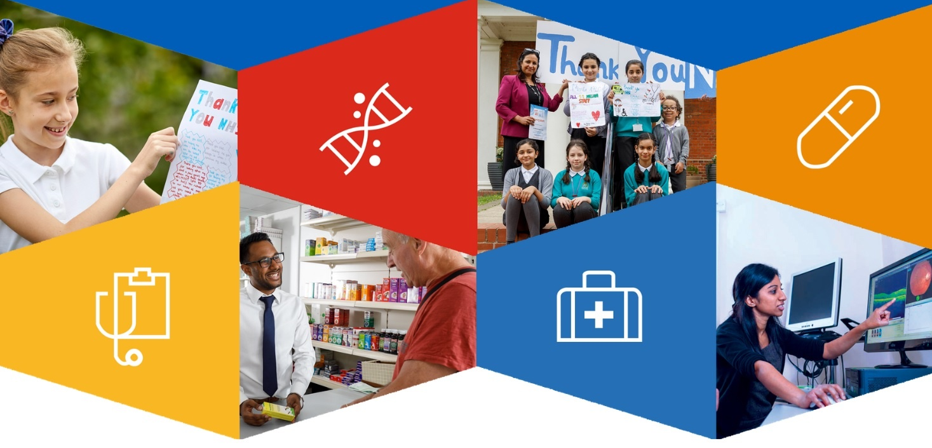
Stakeholder toolkit for primary school competition

Why we need you!
The Step into the NHS primary schools' competition is inviting Key Stage 2 pupils (ages 7 – 11) across England to submit a creative ‘thank you’ to the NHS by 30 April 2021.

It’s an uncertain time for schools. Through Step into the NHS, we are looking to help with fun teaching resources that can be adapted for remote learning. We need your help in spreading the word about this fantastic competition to teachers and schools through your communications channels. Especially those schools local to you, as we know it’s the local messengers that often get schools’ attention.

You could be a competition judge, ambassador, teacher, part of an NHS organisation or another stakeholder involved with career-related learning.

How do I promote the competition?
Below are some suggestions for ways you can promote the competition through your relevant channels.

To help you to with this, we’ve drafted an email and some social media posts which you’ll find later in this document. Please adapt these as you see fit and share via your relevant communications channels. We also have images available and a guide for families on the Step into the NHS resources page.

Online communications – do you or your team have a Twitter account which is networked to other schools? Has your team been utilising social media much more lately thanks to remote working? Is there a public blog, newsletter, or news feed your team distributes which could feature information about the competition?

In schools –If you are teaching remotely, is there space in your background to promote? Are there any planned virtual health career-related visits to the school which you could use to introduce the competition?

School visits – do you or your team co-ordinate (virtual) visits to schools, either locally or nationwide? If so, could you introduce the competition as part of this planned activity using the educator competition pack? The competition has even more impact when health professionals are able to contribute their time to inspire pupils.

In your network – do you have your own Twitter or Linkedin account that you could use to promote the competition? Do you have other educators or career-related professionals in your network that might like to hear about the competition?

Parental engagement – do you have colleagues or friends who are parents of children between 7-11 years old? Could you share information with them to pass on to their child’s school about the competition? You could let them know that we also have a family toolkit available to download from the resources pages of our website. It offers parents guidance on how to support their child’s entry and features prompts to encourage positive conversations about NHS careers.

When do I promote the competition?

It would be wonderful if you could spread word of the competition to your networks. If you’re a teacher, it would be great if you could focus sharing with your network in the first half of the spring term - though promotion at any time is welcome. If you’re an ambassador or stakeholder, it would be appreciated if you can share anytime leading up to the competition deadline which is 30 April.

Key competition dates
Here is the key activity from the Step into the NHS team for you to be aware of:
Schools contacted by email – mid-January, early-March (to tie in with National Careers week) and mid-April
Further school promotion on social media – spring term (January to the end of March), with a final push in the first two weeks of the summer term.
Competition closes – Friday 30 Apr 2021
Judging takes place – May/June 2021
Winners announced – June 2021

Social media

We recommend you use one or a combination of the below posts along with one of the images from the zip file available on the Step into the NHS website.

Don’t forget to @mention any organisations you work with that may be able to retweet or are able to pass the message onto schools.

IMPORTANT: please make sure you include the following in ALL posts:
- the tag #StepIntoTheNHS
- a link to https://www.stepintothenhs.nhs.uk/primary-schools/KS2-competition:

- Looking to inspire your pupils remotely and challenge gender stereotypes? Explore over 350 NHS careers available with engaging and free #StepIntoTheNHS resources.

- Are you a primary school teacher? Ask your pupils to say ‘thank you’ to the NHS with these free and engaging KS2 resources as part of the #StepIntoTheNHS competition!

- Looking for careers-related teaching resources? Inspire your pupils with the #StepIntoTheNHS primary school competition and raise their aspirations!

- Explore free careers resources for your KS2 pupils! With #StepIntoTheNHS, you can introduce your pupils to the breadth of over 350 roles available in the NHS.

- Looking to engage your KS2 class remotely with career-related learning? Inspire your pupils with our ready-made lesson plans and challenge gender stereotypes with #StepIntoTheNHS!

- Discover the #StepIntoTheNHS schools’ competition and the breadth of roles available in the NHS! Learn how it can raise your pupils’ career aspirations and challenge gender stereotypes!

- Do you work with children aged 7-11? Enter the #StepIntoTheNHS competition with them to raise their career aspirations and have the chance of winning great prizes!

- Are you teaching remotely and looking to inspire your pupils to reach their career goals? Access the #StepIntoTheNHS competition resources and enter to do just that!

- Do you have children aged 7-11? Let their school know about the #StepIntoTheNHS competition so they can raise their career aspirations and be in with the chance of winning great prizes!

Engaging with NHS staff online
To supplement these promotional posts, we encourage you to inspire some discussion with your social media audience about pupils and their career aspirations. Ask your audience some questions alongside the hashtag and link above:
- Did you want to work in the NHS when you were a primary school pupil?
- How did you learn about careers when you were at school?
- Do you think there are more health careers today than when you were a pupil at school?
If you work in the NHS or know someone who does, you could share what your/their role is. Especially if the role is not as well-known or challenges gender stereotypes. Don’t forget to tag with #StepIntoTheNHS.

Assets zip file

This toolkit, along with a zip file with approved imagery, is available on the Step into the NHS resources page. These images are for you to use in any comms associated with the competition and are optimised for the channel you intend to use it on. We’ve also included an example school email in the zip file too so you’re aware of what schools have received at the start of the new school year.

Competition video – watch or share on Twitter or Facebook

Email comms

Below is an email with information for schools – feel free to use and/or repurpose for your contacts/relevant ages:

Dear [teacher name],

Calling all KS2 teachers: are you looking to inspire your pupils, learn about NHS careers and challenge gender stereotypes?

Step into the NHS invites all primary schools in England to explore over 350 job roles in the NHS, help raise their pupils’ career aspirations and challenge gender stereotypes by entering the KS2 competition!

Enter the Step into the NHS competition in three simple steps:
- Download the teacher guide including the cross-curriculum resources and lesson plan slides to inspire entries
- Watch the competition video with your class to prepare them to enter
- Submit entries online or post to ‘Freepost STEP INTO THE NHS COMPETITION’

Your school and pupils could be in with a chance of winning amazing prizes and experiences:

- Overall national winner will receive an Amazon voucher worth £50, a certificate and a prize for their class
- Regional winners will each receive an Amazon voucher worth £25 and a certificate
- Highly commended certificates will also be awarded

We look forward to seeing your entries – make sure they’re submitted by Friday 30 April 2021!

Step into the NHS team

Have questions? Email us at: stepintothenhs@hopscotchconsulting.co.uk

About the competition
The Step into the NHS primary competition is a schools’ competition from Health Education England. The competition asks pupils to say ‘thank you’ to the NHS or a team of NHS staff in a creative way – with a card, video, poem or even a song!

Why are we running this competition?

The NHS is the UK’s biggest employer with 1.7 million staff employed in more than 350 different roles. The competition aims to help raise pupils’ ambitions, challenge stereotyping and put learning into context for the future. As one primary school teacher whose class took part in the competition said, “Opening their eyes to career aspirations is really important. I work in an inner-city primary with high levels of socio-economic deprivation and believe it is important to widen our children’s experiences beyond their local communities.”

With so many careers and job roles available within the NHS, from dentists to paramedics and from midwifes to pharmacists, all those involved on the project agree its effectiveness in opening young people’s eyes to a future career in healthcare.
“Many pupils will have heard a lot about the NHS over the course of the pandemic, but they might not have much understanding of the diversity of roles in the NHS or see how they could become a part of it.

Our Step into the NHS programme supports teachers with ready-to-go resources, including lesson plans and fun activities to inspire the next generation of NHS staff.

Through these activities, pupils can learn creatively about career options available to them whatever their skills, interests, gender or background, breaking down stereotypes and helping them to develop job-seeking skills while learning about the NHS.”

- Dr Navina Evans, HEE Chief Executive

How do schools take part?

Taking part requires a teacher to download the teacher guide which includes competition information plus links to the ready-made resources to inspire pupils before they complete their designs.
The redesigned KS2 resources are freely available to teachers on the Step into the NHS website and explore the vast number of careers available in the NHS right now, inspire pupils to think about what the health service will look like in the future and the jobs they could do.
Last year’s competition attracted entries from over 1,870 pupils in 273 schools across England and provided hundreds of schools with relevant and engaging careers content to help raise their pupils’ career aspirations and challenge gender stereotypes. As well as recording the highest number of entries to date, winning entries from 2019/20’s competition have already seen some positive press in the run-up to this year’s competition.

